# [**Law & Order: Organized Crime: Everything You Need to Know About the Stabler Spin-Off**](https://www.tvguide.com/amp/news/nbc-fall-2022-premiere-dates-for-chicago-fire-law-order-svu-la-brea-and-more/)

Here's the latest on Benson and Stabler's upcoming reunion



[**Sadie Gennis**](https://www.tvguide.com/authors/sadie.gennis/)March 25, 2021, 1:34 p.m. PT

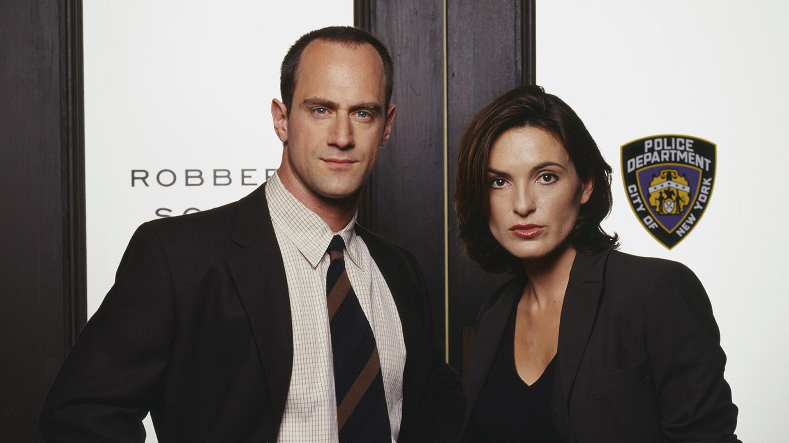

Christopher Meloni and Mariska Hargitay, *Law & Order: SVU*

Chris Haston/NBCU Photo Bank via Getty Images

The hottest TV reunion in recent history is just around the corner. Elliot Stabler ([Christopher Meloni](https://www.tvguide.com/celebrities/christopher-meloni/144798/)) and Olivia Benson ([Mariska Hargitay](https://www.tvguide.com/celebrities/mariska-hargitay/164490/)) will be working together soon during a special episode of [*Law & Order: Special Victims Unit*](https://www.tvguide.com/tvshows/law-order-special-victims-unit/100257/)*,* which will lead into Stabler's new spin-off, *Law & Order: Organized Crime*. It all goes down in a crossover event on April 1.

Meloni starred on *SVU* for the first 12 seasons as Det. Elliot Stabler, whose friendship and partnership with Benson was one of the show's biggest hooks. But in 2011, Meloni shocked viewers when it was announced that [he wouldn't return for the 13th season](https://www.tvguide.com/news/christopher-meloni-exits-svu-1033486/) after his negotiations with the studio fell apart. As a result, the Season 12 finale doubled as Stabler's final episode, and viewers never got a proper goodbye for the beloved character.

Now, the anticipated Stabler spin-off will bring the detective back to our screens in a new show from executive producer [Dick Wolf](https://www.tvguide.com/celebrities/dick-wolf/194137/). Check out everything we know so far about NBC's Elliot Stabler spin-off, *Law & Order: Organized Crime*, below.

**The first footage from Stabler and Benson's reunion is in.** NBC has shared a first look at the moment Benson reunites with Stabler in *SVU*, and it's loaded. Check it out.

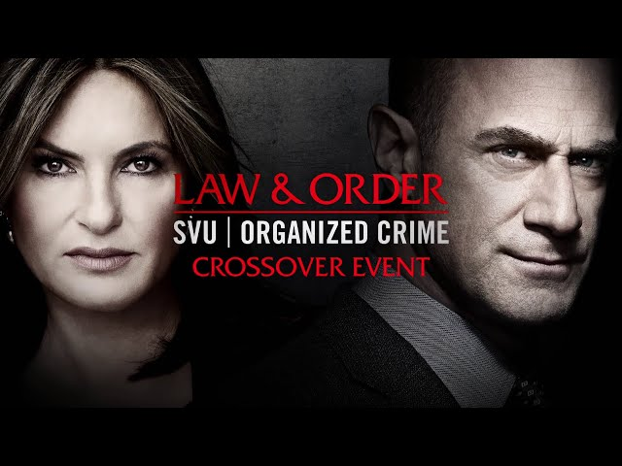

**It premieres April 1.** Elliot Stabler returns in a new crossover episode of *Law & Order: SVU* on Thursday, April 1 at 9/8c on NBC, leading into the [*Law & Order: Organized Crime* premiere](https://www.tvguide.com/news/nbc-spring-premiere-dates-law-and-order-organized-crime-manifest/) at 10/9c on NBC.

**We'll see Stabler's family.** Stabler's wife, Kathy ([Isabel Gillies](https://www.tvguide.com/celebrities/isabel-gillies/154592/)); his daughter Kathleen (Allison Siko); and his son Dickie (Jeffrey Scaperrotta) will appear in the *SVU/Organized Crime* crossover, [Give Me My Remote reports](https://www.givememyremote.com/remote/2021/03/12/svu-organized-crime-crossover-kathy-return-kathleen-dickie/). The two-hour crossover will kick off with an *SVU* episode involving a threat to the Stabler family.

*SVU* showrunner [Warren Leight](https://www.tvguide.com/celebrities/warren-leight/183309/) previously shared on NBC's *SVU* podcast [*The Squadroom*](https://art19.com/shows/the-law-order-svu-podcast/episodes/e455aaeb-2b27-46e3-b43b-c091a927fbc7)that Kathy and one of the couple's two sons, Dickie or Eli, were supposed to return in *SVU*'s Season 21 finale to help set up Stabler's return, before plans for the finale were derailed due to the production shutdown.

"We had heard distant thunder about Chris Meloni coming back in the fall and we were going to lay a little groundwork for that. We were going to see Kathy Stabler come back very upset. Her son has been rolled by a team of ne'er-do-wells and may have been drugged," Leight said on *The Squadroom.*

**Stabler's family life may look different.** When Stabler left *SVU*, he was still married to Kathy and raising their five kids: Maureen, Kathleen, Dickie, Elisabeth, and Eli. But when speaking about the scrapped *SVU* finale that would have seen Kathy and one of their sons return, Leight said the episode would have revealed "what had happened to the Stabler family after Elliot both left SVU and apparently left them."

Does that mean that Stabler and Kathy got divorced? Stabler and Kathy did separate in Season 6 before the pair reconciled in Season 8, but we wouldn't be shocked if the couple decided to go their separate ways in the years since. However, there's always the chance Stabler left his family physically as a result of whatever job he took on post-SVU, but that he remained married to Kathy and the dedicated family man he always aimed to be.

Whatever Leight meant, Meloni shared in July that Stabler's [relationship with his family will have improved](https://www.tvguide.com/news/christopher-meloni-elliot-stabler-changed-in-law-order-organized-crime/) since we saw him last. "I think he's in a good place now with his family. I think he's in a much better place with himself, vis a vis the world," the actor said on *The Jess Cagle Show.*

**New cast members have been reported.** It has been confirmed that [Dylan McDermott](https://www.tvguide.com/celebrities/dylan-mcdermott/3030030764/) will join the series, though details about his new character are still being kept under wraps. Plus, [*Bones*](https://www.tvguide.com/tvshows/bones/1000399820/)' [Tamara Taylor](https://www.tvguide.com/celebrities/tamara-taylor/3000396362/) has been [cast as a lead](https://deadline.com/2021/02/law-order-organized-crime-tamara-taylor-cast-nbc-svu-spinoff-1234685824/), per Deadline. No details about her character have been announced.

**The stars have shared photos from set.** This group shot the show shared in early March on social media has Meloni, Tamara Taylor, Dylan McDermott, and Danielle Mone Truitt smiling for the fans.

In late January, Mariska Hargitay shared photos of her and Meloni on set filming the new series [via Instagram](https://www.instagram.com/p/CKfcDrNHu2W/). "It's all happening..." she captioned the pic of her and her-costar looking very stern and ready to get down to business.

**Stabler has a new job and a new purpose.** Stabler was a detective for Manhattan's 16th Precinct for over a decade before the events of the Season 12 finale spurred his retirement. After killing a young girl who went on a shooting spree in the SVU squad room, Stabler chose to leave the force rather than agree to the terms set by Internal Affairs to keep his job. Now, the spin-off will find Stabler returning to the NYPD to lead the organized crime division "after a devastating personal loss," the official synopsis reads. "However, the city and police department have changed dramatically in the decade he's been away, and he must adapt to a criminal justice system in the midst of its own moment of reckoning. Throughout the series, we will follow Stabler's journey to find absolution and rebuild his life, while leading a new elite task force that is taking apart the city's most powerful criminal syndicates one by one," says the rest of the description.

Meloni added in his TV Guide Magazine [April cover story](https://www.tvinsider.com/991493/law-order-organized-crime-christopher-meloni-stabler-svu-return-preview/) that "Organized crime is not about the old-school Italian mob. It's more of a hybrid, which is international and far more high-tech, [involving] the dark web and cybercrime."

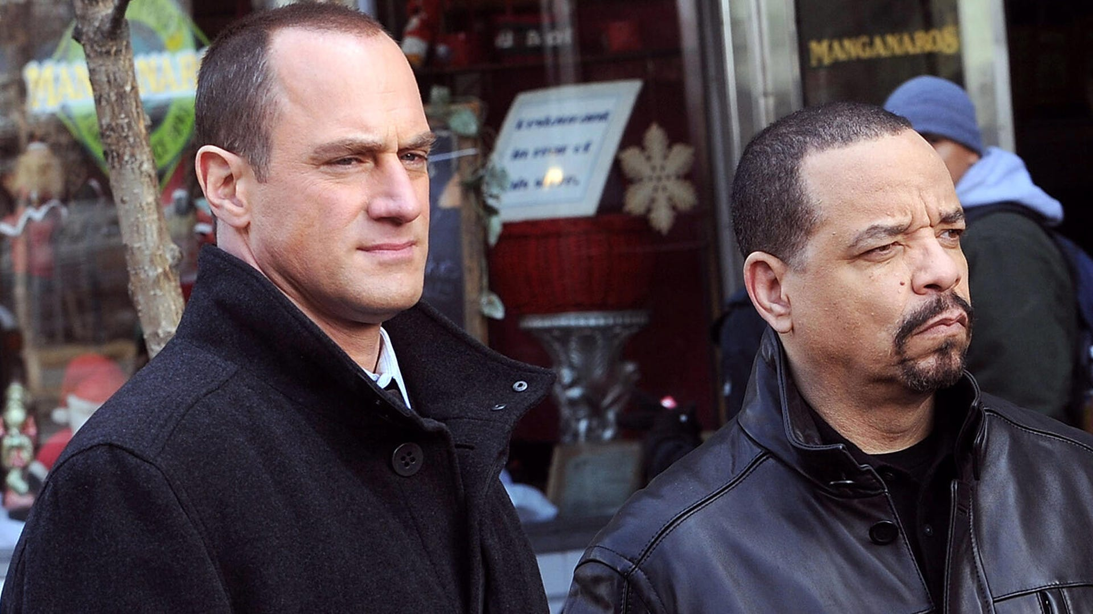

Christopher Meloni and Ice-T filming on location for *Law & Order SVU*

Bobby Bank/WireImage

**We're going to see an "evolved"** **Stabler.** During a July appearance *on The Jess Cagle* *Show,* [Meloni discussed how Stabler will have changed](https://www.tvguide.com/news/christopher-meloni-elliot-stabler-changed-in-law-order-organized-crime/) since viewers saw him last. "I always thought of Elliot, as flawed as he may have been, I think his heart was always in the right place. I think it was his sense of injustice that just brought out the worst aspects of him. I think age, mellowing -- maybe not in his passions, but in how he went about doing his job. He has evolved."

"I think he's going to be coming back into the world -- I think as we're all experiencing right now -- [the world] has really changed with policing and citizenry," Meloni added. "It's a new day and there are new ways of going about things. I think those are all issues to be addressed in the show and I think it's going to be a challenge for Elliot. One that I think he's going to meet."

Stabler's decade away from SVU has definitely changed him. [Meloni revealed](https://www.tvinsider.com/991493/law-order-organized-crime-christopher-meloni-stabler-svu-return-preview/), "He wanted to get far away from the sense of betrayal he felt from the NYPD. But bitter is no way to go through life. He needed to heal himself, which started with healing his relationship with his wife. That made him a better man who's better equipped to handle things."

[Paul Wesley, Mark-Paul Gosselaar, and More Recall Their Guest Roles on Law & Order: SVU](https://www.tvguide.com/news/law-order-svu-anniversary-guest-stars/)

**The show has a new showrunner.** [*Chicago P.D*.](https://www.tvguide.com/tvshows/chicago-pd/556344/)'s [Matt Olmstead](https://www.tvguide.com/celebrities/matt-olmstead/283017/) was the original showrunner of *Organized Crime*, but in October, *The Hollywood Reporter* revealed [Olmstead had departed the series](https://www.hollywoodreporter.com/live-feed/chris-melonis-law-order-svu-spinoff-delayed-at-nbc-amid-showrunner-change-exclusive?utm_source=Sailthru&utm_medium=email&utm_campaign=THR%20Breaking%20News&utm_term=hollywoodreporter_breakingnews) amid challenges in "cracking the show's creative." [*Empire*](https://www.tvguide.com/tvshows/empire/1000632276/)'s Ilene Chaiken [took over showrunner duties in December.](https://variety.com/2020/tv/news/law-order-organized-crime-ilene-chaiken-1234850039/)

**Stabler was supposed to return in the *SVU* Season 22 premiere.**In the spring of 2020, *SVU* showrunner Warren Leight revealed on NBC's *SVU* podcast [*The Squadroom*](https://art19.com/shows/the-law-order-svu-podcast/episodes/e455aaeb-2b27-46e3-b43b-c091a927fbc7)that Stabler was originally first going to appear in *SVU*'s season premiere."Whether we'll get to see his family as well remains to be seen," Leight said. "There's a lot of moving parts. They're launching a new series as well. So it's not just about the *SVU* season opener, it's how do we help launch the new series and how much crossover will there be between Elliot and Olivia as the season goes on." Though Stabler's return didn't wind up happening in the *SVU* season premiere, his new series will still be launched with an *SVU* crossover.

**Stabler and Benson will explore "unresolved emotions" when they** **reunite.** During an interview with the *New York Post,* [Meloni shared his expectations](https://www.tvguide.com/news/christopher-meloni-benson-stabler-reunion-law-order-crossovers/) for the former partners' upcoming reunion. "Benson and Stabler are inextricably linked, locked and connected. I think there is truly and deeply a worthwhile, inherent drama in exploring that relationship and the complexity of how Stabler left — the unresolved emotions both characters feel and how the fans feel," the actor explained.

"I just think there will always be possibilities there," Meloni said of exploring Benson and Stabler's relationship. "People will always be hungry to see how we interact and how that dynamic has changed."

[21 Seasons In, *Law & Order: SVU* Still Feels as Vital As Ever](https://www.tvguide.com/news/law-order-svu-season-21-legacy/)

**There will probably be more *SVU* crossovers to come.** Stabler's appearance in the *SVU* premiere will hopefully be the beginning of many crossovers between the long-running procedural and the upcoming spin-off. "It almost feels that we won't do one or two [crossover] episodes and move on our merry way," [Meloni told](https://www.tvguide.com/news/christopher-meloni-benson-stabler-reunion-law-order-crossovers/) the *New York Post.*

[Meloni shared a bit more](https://www.tvinsider.com/991493/law-order-organized-crime-christopher-meloni-stabler-svu-return-preview/) with TV Guide Magazine about Stabler and Benson working together, "The first eight episodes will be about one crime. Elliot was doing an investigation somewhere else, then followed a lead to New York, where it's causing him problems. Benson tries to help and then she's called off the case. He goes on to investigate with her help every once in a while."

Although Leight pointed out on *The Squadroom* that there is currently no room for the spin-off on the stages where *SVU* films (which would have made crossovers even easier), both shows are based in NYC, and we can't imagine the producers not taking advantage of every crossover opportunity -- especially since they're already doing this so well with One Chicago.

*Law & Order: Organized Crime* premieres Thursday, April 1 at 10/9c on NBC, following a special crossover episode of *SVU* at 9/8c.

*Law & Order: SVU* is available to stream at [NBC](https://www.nbc.com/law-and-order-special-victims-unit/episodes) and [Hulu](https://click.linksynergy.com/fs-bin/click?id=Bs9ZhlULz2w&offerid=615841.58&type=3&subid=editorial).

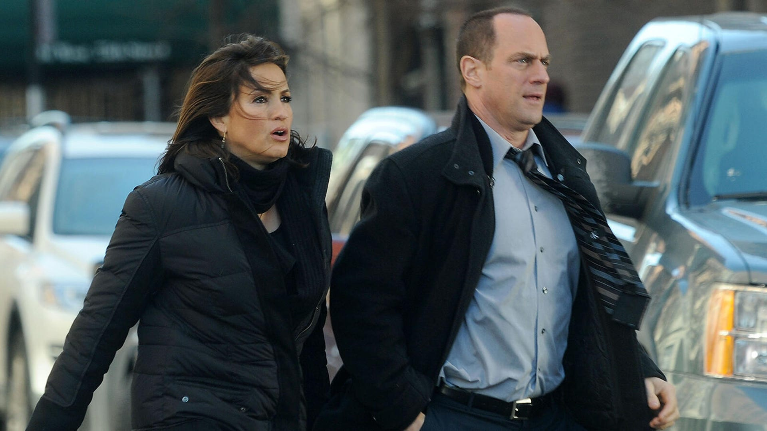

Mariska Hargitay and Christopher Meloni on location for *Law & Order: SVU*

Bobby Bank/WireImage

# **NBC Fall 2022 Premiere Dates for Chicago Fire, Law & Order: SVU, La Brea, and More**

You may have to wait a while for Magnum, P.I.



[**Megan Vick**](https://www.tvguide.com/authors/megan.vick_tvg/)Sept. 9, 2022, 4:22 p.m. PT

NBC's fall TV season is about to debut, and there's a lot to be excited about in the peacock network's 2022 schedule, starting with two fan-favorite franchises. One Chicago ([*Chicago Fire*](https://www.tvguide.com/tvshows/chicago-fire/1000452546/)*,* [*Chicago Med*](https://www.tvguide.com/tvshows/chicago-med/1000603015/)*,* [*Chicago P.D.*](https://www.tvguide.com/tvshows/chicago-pd/1000541233/)) will return on Wednesday, Sept. 21, and the three Law & Order series ([*Law & Order*](https://www.tvguide.com/tvshows/law-and-order/1030143566/),[*SVU*](https://www.tvguide.com/tvshows/law-and-order-special-victims-unit/1000009212/), and [*Organized Crime*](https://www.tvguide.com/tvshows/law-and-order-organized-crime/1030802906/)) will follow up on Thursday, Sept. 22.

Kicking off after *The Voice* on Monday, Sept. 19 is the anticipated [*Quantum Leap*](https://www.tvguide.com/tvshows/quantum-leap/1030242396/) revival starring [Raymond Lee](https://www.tvguide.com/celebrities/raymond-lee/3030469111/) as Ben Song, a man in charge of a new physics team that restarts the Quantum Leap project to try and solve the mysteries created when Sam Beckett ([Scott Bakula](https://www.tvguide.com/celebrities/scott-bakula/3030030779/)) stepped into the time jumping machine three decades ago. Meanwhile, new comedy *Lopez vs Lopez* from George Lopez will premiere with Season 3 of *Young Rock* on Friday, Nov. 4.

The final season of [*New Amsterdam*](https://www.tvguide.com/tvshows/new-amsterdam/1000778886/) kicks off on Tuesday, Sept 20 at 10/9c, and [*La Brea*](https://www.tvguide.com/tvshows/la-brea/1000898094/) returns on Tuesday, Sept. 27, when *The Voice* goes down to one hour on its second night.

But if you're looking for a premiere date for [*Magnum P.I.*](https://www.tvguide.com/tvshows/magnum-pi/1000289094/), which NBC rescued and renewed for two seasons after it was scrapped by CBS this spring, you're in for a bit of a wait; production on *Magnum* is underway, and we're unlikely to see new episdoes before midseason, at the earliest.

See the complete list of NBC's 2022 fall TV premiere dates below, [check out trailers for the new shows](https://www.tvguide.com/news/nbc-lineup-all-the-new-shows-and-trailers-coming-in-fall-2022/), and see the full [2022 fall TV premiere date schedule](https://www.tvguide.com/news/fall-2022-broadcast-tv-premiere-dates-abc-cbs-fox-nbc-cw-new-and-returning-shows/) for new and returning shows across all networks.

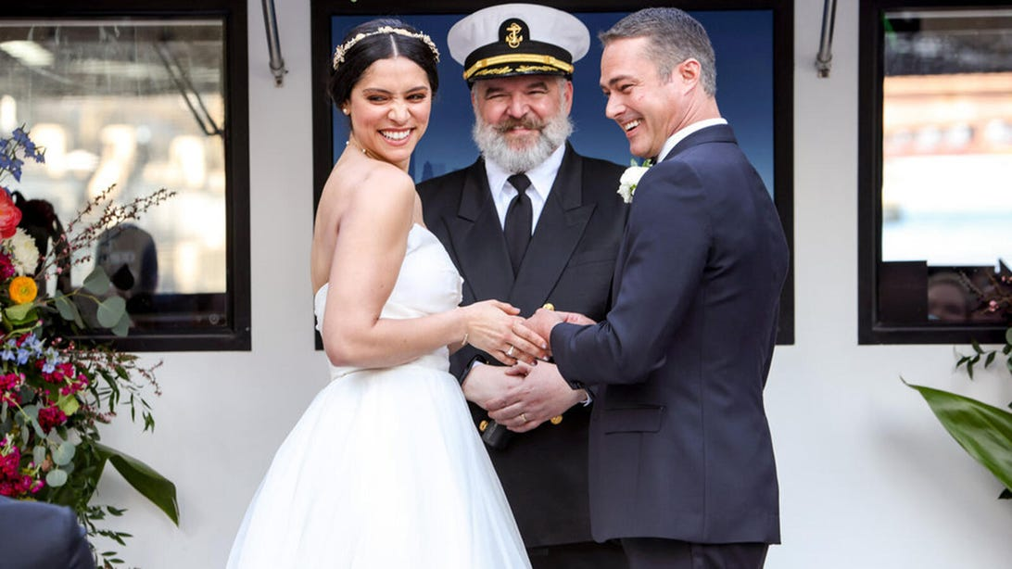

Miranda Rae Mayo and Taylor Kinney, *Chicago Fire*

NBC

**Monday, Sept. 19**  
**8 p.m.:** *The Voice*  
*10 p.m.: Quantum Leap*

**Tuesday, Sept. 20**  
**8 p.m.:** *The Voice*  
*10 p.m.: New Amsterdam*

**Wednesday, Sept. 21**  
**8 p.m.:** *Chicago Med*  
*9 p.m.: Chicago Fire*  
*10 p.m.: Chicago PD*

**Thursday, Sept. 22**  
**8 p.m.:** *Law & Order*  
*9 p.m.: Law & Order: SVU*   
10 p.m.: *Law & Order: Organized Crime*

**Saturday, Sept. 24**  
**9 p.m.:** *Dateline Weekend Mystery*  
*10 p.m.: SNL Vintage*

**Tuesday, Sept. 27**  
**9 p.m.:** *La Brea*

**Friday, Nov. 4**  
**8 p.m.:** *Lopez vs Lopez*  
*8:30 p.m.: Young Rock*